**Practical no.-**07

**Title:** Develop a program to implement Text View and Edit Text.

**Roll No.:**15 **Batch-** A **Date of Performance:** 05/02/2024



<?xml version="1.0" encoding="utf-8"?>

<AbsoluteLayout

xmlns:android="http://schemas.android.com/apk/res/android"

xmlns:tools="http://schemas.android.com/tools"

xmlns:app="http://schemas.android.com/apk/res-auto"

android:layout_width="match_parent"

android:layout_height="match_parent"

tools:context=".MainActivity">

<TextView

android:layout_width="wrap_content"

android:layout_height="wrap_content"

android:layout_x="10dp"

android:layout_y="33dp"

android:text="Student Application Form"

android:textAlignment="center"

android:textColor="#FF0000"

android:textSize="30dp"

android:textStyle="bold"></TextView>

<TextView

android:layout_width="wrap_content"

android:layout_height="wrap_content"

android:layout_x="22dp"

android:layout_y="118dp"

android:text="Name"

android:textAlignment="center"

android:textSize="25dp"

android:textStyle="bold">

</TextView>

<EditText

android:layout_width="wrap_content"

android:layout_height="wrap_content"

android:layout_x="145dp"

android:layout_y="113dp"

android:ems="10"

android:hint="Enter your Name"

android:inputType="text"

tools:ignore="TouchTargetSizeCheck" />

<TextView

android:layout_width="wrap_content"

android:layout_height="wrap_content"

android:layout_x="22dp"

android:layout_y="182dp"

android:text="CRN"

android:textAlignment="center"

android:textSize="25dp"

android:textStyle="bold">

</TextView>

<EditText

android:layout_width="wrap_content"

android:layout_height="wrap_content"

android:layout_x="145dp"

android:layout_y="249dp"

android:ems="10"

android:hint="Enter Branch"

android:inputType="text"

android:minHeight="48dp" />

<TextView

android:layout_width="wrap_content"

android:layout_height="wrap_content"

android:layout_x="22dp"

android:layout_y="251dp"

android:text="Branch"

android:textAlignment="center"

android:textSize="25dp"

android:textStyle="bold">

</TextView>

<EditText

android:layout_width="wrap_content"

android:layout_height="wrap_content"

android:layout_x="145dp"

android:layout_y="179dp"

android:ems="10"

android:hint="Enter your CRN number"

android:inputType="text"

android:minHeight="48dp" />

<TextView

android:layout_width="wrap_content"

android:layout_height="wrap_content"

android:layout_x="22dp"

android:layout_y="322dp"

android:text="Class"

android:textAlignment="center"

android:textSize="25dp"

android:textStyle="bold">

</TextView>

<EditText

android:layout_width="wrap_content"

android:layout_height="wrap_content"

android:layout_x="145dp"

android:layout_y="325dp"

android:ems="10"

android:hint="Enter Class"

android:inputType="text"

tools:ignore="TouchTargetSizeCheck" />

<TextView

android:layout_width="wrap_content"

android:layout_height="wrap_content"

android:layout_x="22dp"

android:layout_y="395dp"

android:text="Division"

android:textAlignment="center"

android:textSize="25dp"

android:textStyle="bold">

</TextView>

<EditText

android:layout_width="wrap_content"

android:layout_height="wrap_content"

android:layout_x="145dp"

android:layout_y="394dp"

android:ems="10"

android:hint="Enter Division"

android:inputType="text"

android:minHeight="48dp"

tools:ignore="TouchTargetSizeCheck" />

<TextView

android:layout_width="wrap_content"

android:layout_height="wrap_content"

android:layout_x="22dp"

android:layout_y="461dp"

android:text="DOB"

android:textAlignment="center"

android:textSize="25dp"

android:textStyle="bold">

</TextView>

<TextView

android:layout_width="wrap_content"

android:layout_height="wrap_content"

android:layout_x="22dp"

android:layout_y="516dp"

android:text="Mobile No."

android:textAlignment="center"

android:textSize="25dp"

android:textStyle="bold">

</TextView>

<EditText

android:id="@+id/editTextPhone"

android:layout_width="wrap_content"

android:layout_height="wrap_content"

android:layout_x="145dp"

android:layout_y="513dp"

android:ems="10"

android:hint="Enter Mobile Number"

android:inputType="phone"

android:minHeight="48dp"

tools:ignore="TouchTargetSizeCheck" />

<TextView

android:layout_width="wrap_content"

android:layout_height="wrap_content"

android:layout_x="22dp"

android:layout_y="589dp"

android:text="Address"

android:textAlignment="center"

android:textSize="25dp"

android:textStyle="bold">

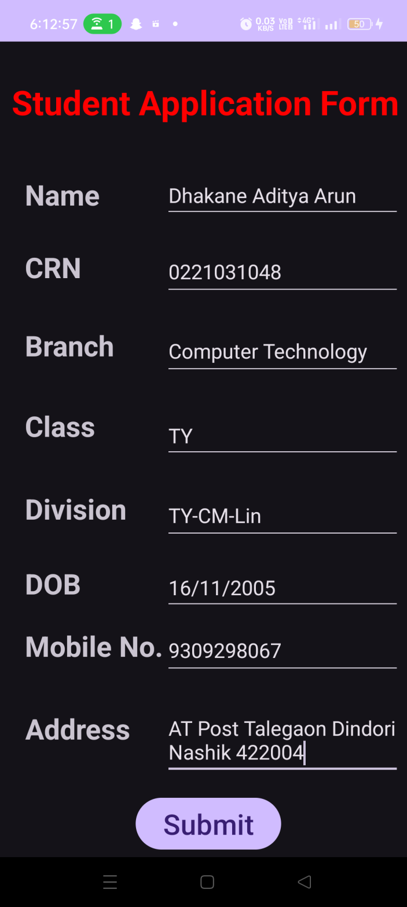 </TextView>

<EditText

android:id="@+id/editTextTextMultiLine"

android:layout_width="wrap_content"

android:layout_height="wrap_content"

android:layout_x="145dp"

android:layout_y="583dp"

android:ems="10"

android:gravity="start|top|center_horizontal"

android:inputType="textMultiLine"

android:hint="Enter Your Permanent Address"/>

<Button

android:id="@+id/button"

android:layout_width="wrap_content"

android:layout_height="wrap_content"

android:layout_x="120dp"

android:layout_y="663dp"

android:text="Submit"

android:textSize="25dp" />

<EditText

android:id="@+id/editTextDate"

android:layout_width="wrap_content"

android:layout_height="wrap_content"

android:layout_x="145dp"

android:layout_y="459dp"

android:ems="10"

android:inputType="date"

android:hint="Enter Date of Birth"/>

</AbsoluteLayout>